

WEB APPLICATION Training Guide
C-BIG Budget Input

Office of Academic Planning & Budget
Updated August 2021

Contents

C-BIG Web Budget Input 3
1. Access the Web Application 3
2. View the Fund Check Report 3
3. Access the Budget Input Forms 5
4. Using Budget Input Forms 6
4a. Selecting Department & Fund 7
4b. Inputting and Submitting Budget Data 8
4c. Adding Cell Comments 9
4d. Adding Supporting Details 9
4e. Adjust 11
4h. Running Calculations 12
5. Data Validation 13
5a. Deficit Budget Check 13
5b. Spread Check 13
6. Approval Process 13
7. Logging Off Smart View 14
8. Troubleshooting 14

C-BIG Web Budget Input
The C-BIG web application is the alternative to entering the budget through Smart View (Excel). Data entered in Smart View or the web application go to the same database.
If any questions come up during your review of the information, please feel free to contact APB at apbcbig@ponet.ucla.edu, or contact someone from the APB Financial Analysis & Decision Support Team.

1. Access the Web Application
To access the web application,
- Go to the C-BIG application: https://planning-ehjw.pbcs.us2.oraclecloud.com/HyperionPlanning
- Log in using your C-BIG login and password – you should see the screen below:
  - Contact APB at apbcbig@ponet.ucla.edu if you forgot your password and need a password reset.
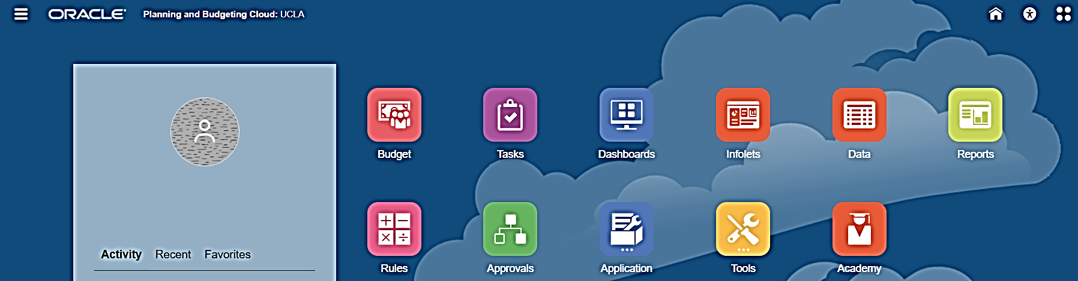

2. View the Fund Check Report
View the Fund Check report to see what funds are required for budget input.
- On the homepage of the C-BIG application, click the Reports icon:
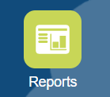
- In the list of Financial Reports, click Home > UCLA > 02 Budget Input Reports > Prelim:

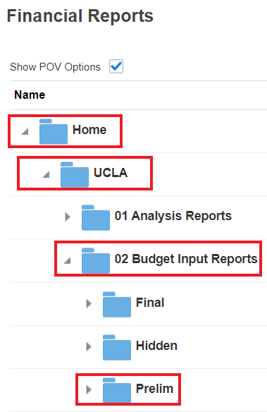
 | The Prelim folder is used during the annual budget input process. The Final folder is used after year end for the adjusted budget process (for any material changes to your original budget submission).

- In the Prelim folder, double-click 15 Bud Input – Org & Fund Check:
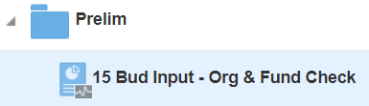
- Open the report in HTML, PDF, or Excel Format.
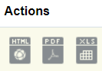

- When the prompt appears, enter your org or department number in the following format: org_#### or dpt_####. Click on Continue.


3. Access the Budget Input Forms
- Select the Budget icon:

- On the left hand side of your window, you will see 6 different icons:
  - Check CBIG Report: 
  - Beginning Budget Form: 
  - Budget Seasonality Quarterly Form: 
  - Budget Seasonality Monthly Form:
  - Check CBIG Report: 
  - Review Budget Input by Org Dpt:

- Select the Beginning Budget Form (Second Icon located on the left-hand side of the window):

- Enter your department number and fund number: dpt_#### and fnd_#####
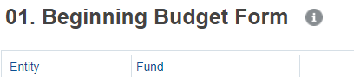

Build Beginning Budget Form:
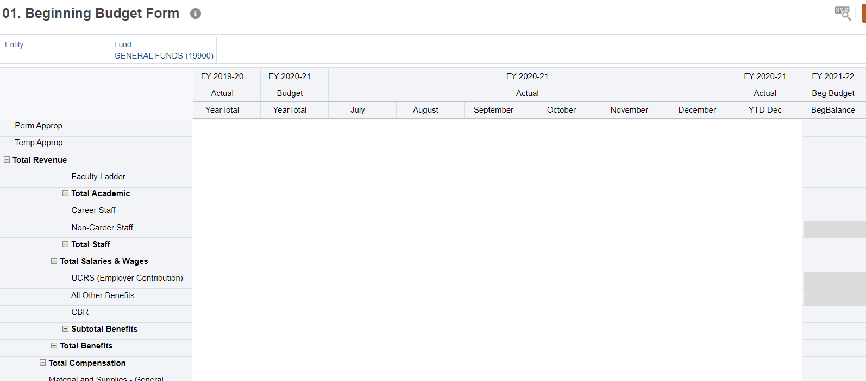
Note: Historical actual and budget numbers will show on this form – this form is blank for the purpose of not displaying any department’s numbers
Budget Seasonality Form (Quarterly or Monthly):
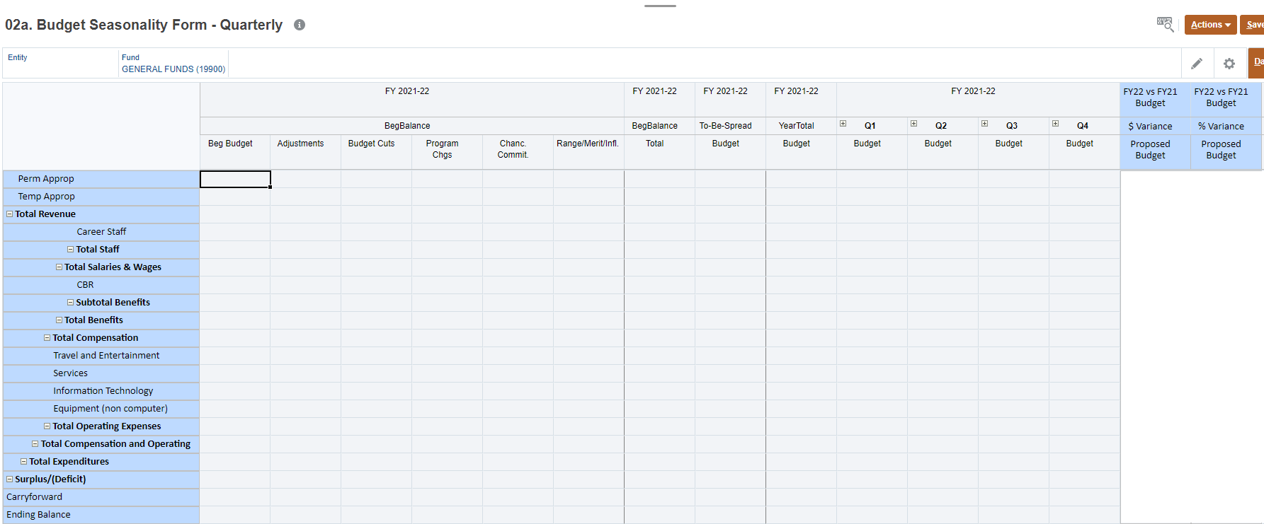

4. Using Budget Input Forms
The list of Budget reports contains the two budget input forms seen in section 3. These include “2.0 Build Beginning Budget form” and “02a. Budget Seasonality Form - Quarterly”. Instead of the quarterly form, you can choose to input into the monthly form “02b. Budget Seasonality Form - Monthly”.

4a. Selecting Department & Fund
There are member selection menus on the input forms you have opened in the CBIG Web Application. The “Entity” menu allows you to select your department, and the “Fund” menu allows you to select your fund. After changing your selection, you must click the Refresh button to reflect the changes.

To change your department,
- Select a department from the “Entity” menu by clicking through available departments or use the “Search Entity” search box. Click OK after you have selected your department:
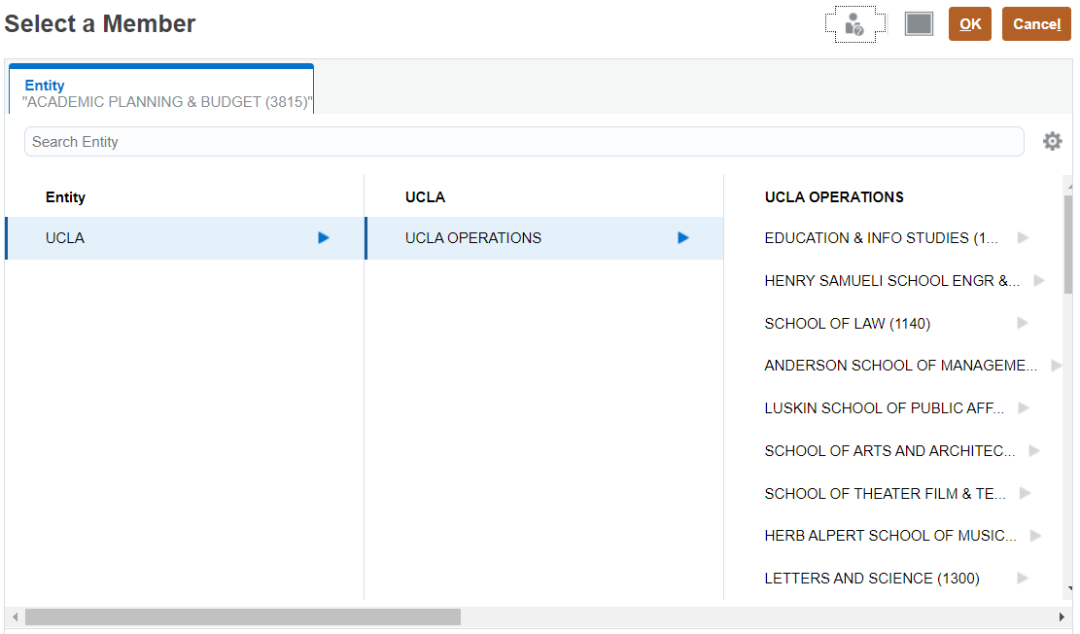
- After selecting your department, click on the arrow

- Select a fund from the “Fund” menu and click OK:
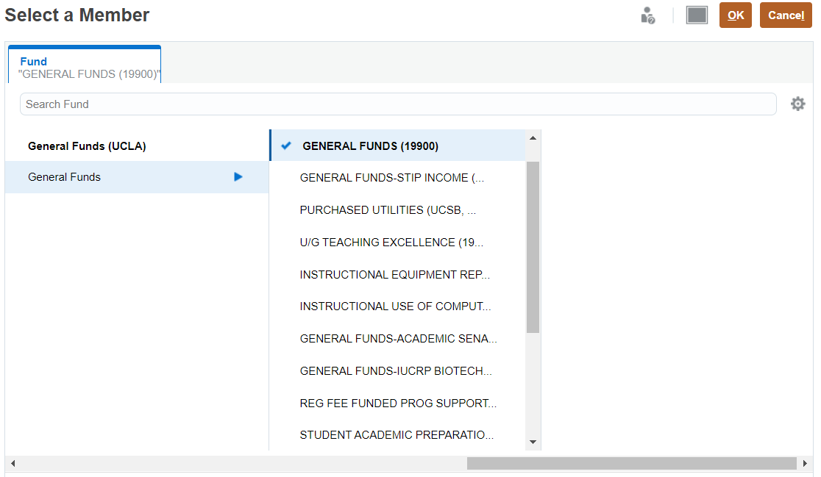

- After selecting the fund, click on the arrow

4b. Inputting and Submitting Budget Data
The cells with a light grey background color represent read-only cells, while those with a white background color represent input cells. After inputting data, the cell color will change to yellow, indicating that data has been changed but not yet submitted/saved to the database.
To submit/save your changes,
- Click on Save on the top right hand corner of the budget form:

- If you get an error or the data will not submit (data disappears), please click Refresh and try again. If you are still having problems submitting data, please contact APB at apbcbig@ponet.ucla.edu, or contact someone from the APB Financial Analysis & Decision Support Team.

If, instead of saving your data, you would like to delete your unsaved changes:
- Click on Refresh
- At the following prompt, click on the OK button to confirm the Refresh command:
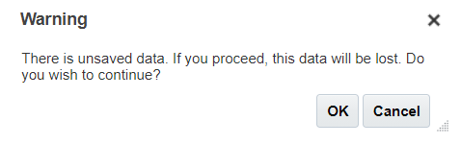

4c. Adding Cell Comments
To add Cell Comments,
- Select a single cell.
- Click on Actions > Comments on the top right hand corner of the budget form:
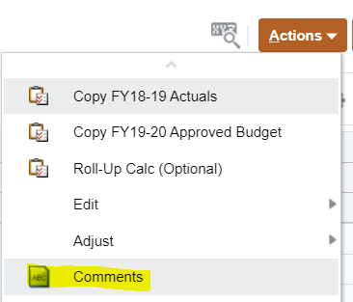

- Once the Comments window appears, add your comments, and click Post. You can also insert attachments by clicking on the paper clip icon:
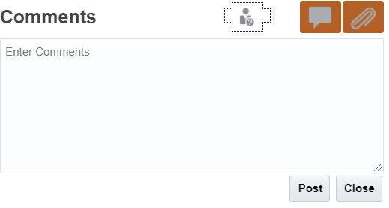

4d. Adding Supporting Details
Supporting details are used to provide more detail behind a number. To add Supporting Details,
- Select a cell.
- Click on Actions > Supporting Details on the top right corner of the window:
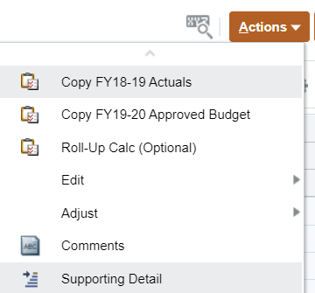

- The Supporting Detail window will appear. Select Actions > Add Child button:

- Type a description over the default “Untitled”, select an operator, enter an amount, and click Save:
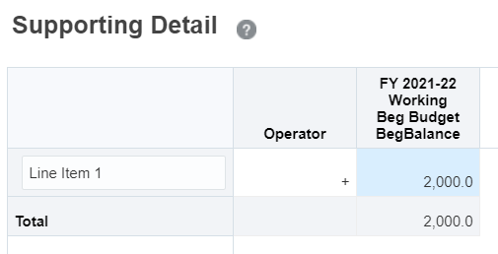
- To add line items, select the Add Sibling button.
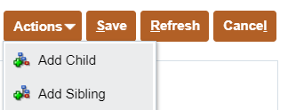

- Type in a description, an operator, an amount for the additional rows and click on the Save button when done.

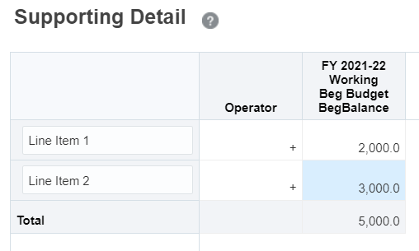

The total amount will display on your form, and the cell background color will appear in blue, indicating that there are Supporting Details.
To delete Supporting Details, simply go to Actions > Supporting Details > Delete or Delete All.

4e. Adjust
Cells can be adjusted by value or fixed percentage. To use the adjust function, highlight the cells you would like to change in a form, and in the Actions drop down menu, go to Adjust > Adjust Data.
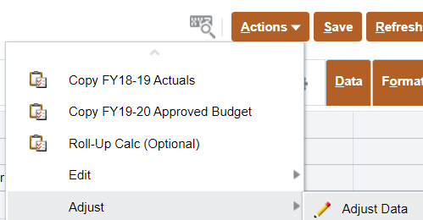
Insert an adjustment as either a dollar or percentage change and then click Apply.
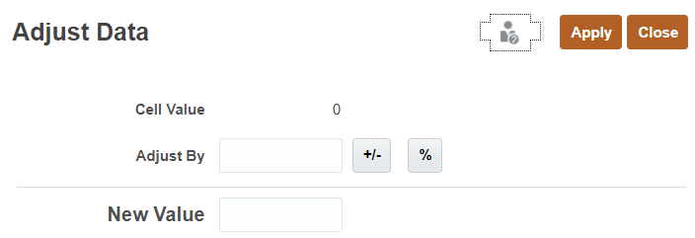

4h. Running Calculations
Calculations, or business rules, are available for the forms. There are three rules available from the Beginning Budget Form and Budget Seasonality Form.
To access the business rules,
- Right-click on a row within the form and select Business Rules. This can also be accessed by selecting Actions in the top right corner of the form > Business Rules.

Beginning Budget Form:
The business rules for the Beginning Budget Form will populate Salaries and Operational Expense rows on the form. Users may right-click ANY of the rows (e.g. Faculty Ladder) and select a calculation to run for all the Salaries and Operational Expense rows:
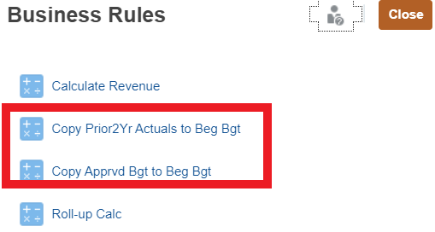
Budget Seasonality Form:
Business rules available for the Budget Seasonality Quarterly/Monthly Form are run for selected rows. Therefore, it is important that you right-click on the specific row you would like to alter.
To apply the calculation to multiple rows, right-click on the appropriate subtotal/parent row, then select the calculation (e.g. Selecting Total Salaries & Wages would apply the calculation to Faculty Ladder, Faculty Temporary, Academic Apprentice, Academic Other, Career Staff, and Non-Career Staff rows).
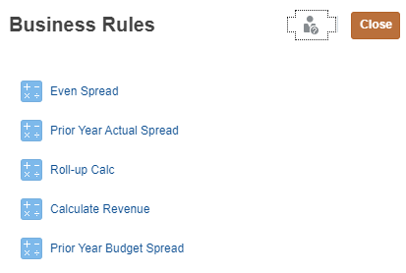

5. Data Validation
Data validation has been built in to the Beginning Budget Form and Budget Seasonality Quarterly/Monthly Form. There are two types of data validation: Deficit Budget Check and Spread Check.

5a. Deficit Budget Check
If you enter a budget that results in a deficit at the Ending Balance row, Total or YearTotal columns, the cell will be highlighted in yellow. You may also notice a Data Validation Message, stating, “Please resolve the deficit budget prior to submitting” when the cell is highlighted. You must correct the deficit budget; however, the system will not prevent you from submitting deficit budgets for approval.
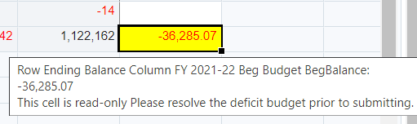

5b. Spread Check
The Budget Seasonality Form will also check for To-Be-Spread amounts for each input row. If the To-Be-Spread amount is greater than 1 or less than -1 on a data input cell, the cell will be highlighted in yellow and a Data Validation message stating, “Please adjust your spread to match the annual budget entered” will appear. All To-Be-Spread issues must be resolved prior to submitting your budget.
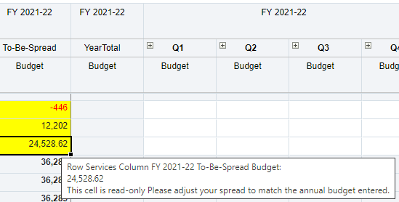

6. Approval Process
The Approval process will NOT take place in C-BIG for the 2021-22 Budget Year. C-BIG users will be locked out of the system by the budget submission deadline.

7. Logging Off Smart View
To log off, click on the white arrow in the top right corner of the webpage and select Sign Out.
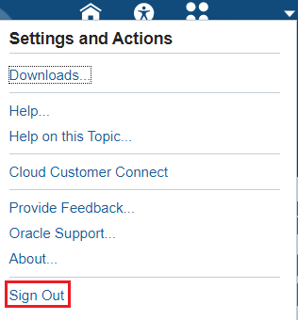

8. Troubleshooting
In the case that an error message appears while inputting budget, or your data cannot be submitted, please ensure that you are accessing the latest version of the CBIG Web Application APB C-BIG webpage under the Application Links section.
Do not hesitate to contact APB at apbcbig@ponet.ucla.edu, or contact someone from the APB Financial Analysis & Decision Support Team.

